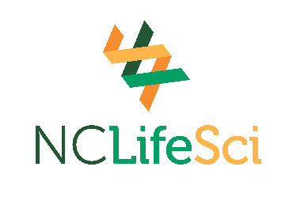
2026-2027 Samuel M. Taylor Memorial Life Sciences Scholarship Application

Instructions: Complete this application and return it to the college Financial Aid Office by Friday, July 31, 2026.

Scholarship Name: Samuel M. Taylor Memorial Life Sciences Scholarship

Student Information:

First Name: ________________________ MI: _____ Last Name: _______________________

Address: ____________________________________________________________________

City: ________________________________ State: ___________ Zip Code: ______________

Phone: ___________________ E-Mail Address: _____________________________________

Community College Name: _____________________________________________________

Check the program below that you are enrolled in. Grade Point Average (GPA): ________

_____ Clinical Research Associate

_____ Facility Maintenance Technology

_____ Biotechnology - Bioanalytical Laboratory Technology

_____ Biotechnology - Bioprocess Manufacturing Technology

Please submit an essay outlining your interest in the life sciences field. In your response, describe your academic and career goals, and explain how receiving this scholarship will help support you financially in reaching your educational objectives.

Acknowledgement and Certification: I have read and understand the requirements for the scholarship I am applying for. I certify that the information provided on this form is complete and correct to the best of my knowledge.

Applicant’s Signature: _____________________________________ Date: _____________
Colleges must submit student applications and essays electronically to Financial Aid Term Scholarship Reporting at fatsr@nccommunitycolleges.edu by Friday, July 31, 2026. Applications received after July 31, 2026, may not be considered.

