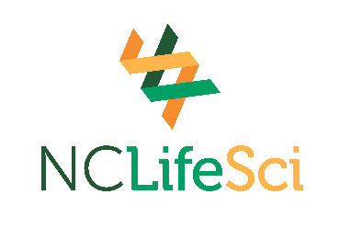
2026-2027 Samuel M Taylor Memorial Life Sciences Scholarship
The Samuel M. Taylor Memorial Life Sciences Scholarship was established in memory of Sam Taylor, a founder and president of NCLifeSci, the trade association for life science companies in North Carolina. Sam was passionate about North Carolina’s life sciences industry and served at NCLifeSci’s helm for more than 25 years. He was instrumental in the establishment of the NCBioImpact training program to support the growth of biopharma manufacturing in our state and ensure training opportunities for North Carolinians seeking a career in the industry. BioNetwork, the life science training initiative of the NC Community College System, is a key member of the NCBioImpact collaborative. To learn more, visit: www.ncbionetwork.org/sam-taylor-scholarship
Student Eligibility Requirements
Qualifying applicants must meet the following criteria:
- Be a North Carolina resident for tuition purposes.
- Be enrolled in one of the programs listed below:
  - Clinical Research Associate
  - Facility Maintenance Technology
  - Biotechnology – Bioanalytical Laboratory Technology
  - Biotechnology – Bioprocess Manufacturing Technology

- Meet satisfactory academic progress requirements of the community college. Must maintain a minimum 2.00 GPA at the end of each semester.
- Continuous enrollment in one of the listed programs for the duration of the scholarship at the college where enrolled at the time of the scholarship award.
- Complete the Free Application for Federal Student Aid (FAFSA) at www.studentaid.gov
- Complete the NCCCS application for the Samuel M. Taylor Memorial Life Sciences scholarship.
- Include an essay outlining your interest in the life sciences field. In your response, describe your academic and career goals and explain how receiving this scholarship will help support you financially in reaching your educational objectives.
- Applicants should return the completed application and essay to the college’s financial aid office by Friday, July 31, 2026.
College Requirements
- Colleges must submit student applications and essays electronically to Financial Aid Term Scholarship Reporting at fatsr@nccommunitycolleges.edu by Friday, July 31, 2026. Applications received after July 31, 2026, may not be considered.

*Preference may be given to students with limited financial aid from other programs. Scholarship candidates shall be selected, and the scholarships awarded without regard to race, gender, color, creed, religious preference, age, national origin or disability.
*Factors considered in the selection process include but are not limited to financial need, scholarship achievement, designated goals, and demonstrated interest in pursuing a life science career in NC.
*Recipients of the scholarships will be selected each year by the scholarship committee of the NC Community College System along with individuals designated by NCLifeSci.
.

