- Title: Quality Management Systems for Craft Brewing
  - Target delivery date, if applicable: TBD
  - Image
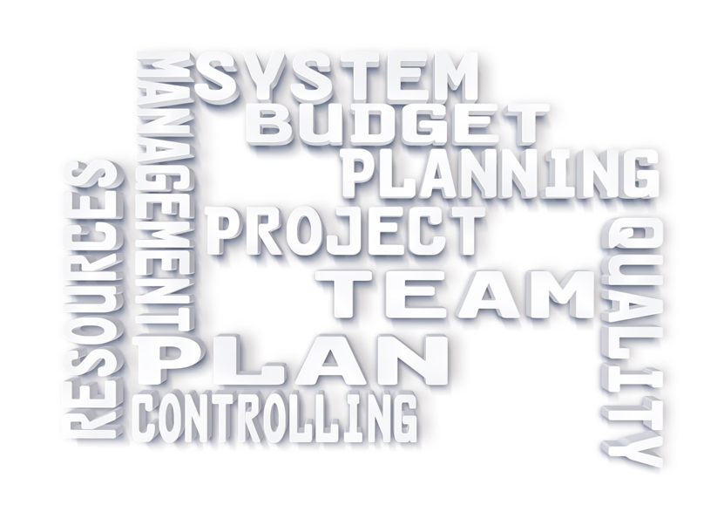
- Form contents last revised date: 01/31/22
- Catalog/ website course description: This course focuses on the important factors involved in a quality management system. This includes management buy-in, communication, quality goals, regulatory requirements, statistical analysis, and process controls, and how they all apply to breweries. Students will review laboratory analysis procedures and data analysis for sensory, chemical, microbiological, and packaging concerns.
- Course length:
  - 6 Lecture hours
2 Activity hours
  - 8 total contact hours
- Student to Instructor/Technician ratio: 25:1 recommended
- Learning objectives:
  - Understand the fundamentals of a quality management system (QMS)
  - Recognize the purpose and importance of QMS
  - Be able to trend and analyze quality data, apply regulatory requirements, and identify common spoilage organisms
  - Identify the different types of sensory analysis, different test types and sampling techniques
  - Understand the basics of statistics and data trending
- Target industry: Craft brewing industry
- Primary audience: Quality control, production employees, management
- Portability: Yes
  - If N to Q9 above, location taught: N/A
- Prerequisites, if applicable: N/A
- Instructor credentials or qualification requirements, if applicable: N/A
- Is there an industry standard, state, or national certification for this course: No
  - If yes to Q12 above, list certification entity & website URL: N/A
- Standards and reference material:
- Suggested key terms:
  - Sensory analysis, quality assurance, data trending, statistics, shelf-life analysis
  - ABV, IBU, pH, dissolved O2, clarity, haziness
  - Triangle test, PCR, VDK distillation
- Description and objectives of student hands-on exercises:
  - Statistical Process Controls: To gain a better understanding of how raw data translates to real life quality issues, participants will be given a sample of several different types of data. After careful consideration in their groups, they will be asked to explain their justification as to whether the data should result in a correction or not.
  - Communication Scenarios: Participants will be split into groups and given different scenarios that will require them to determine the best path forward regarding open and respectful communication. They will be asked to explain their rationale in the hopes of educating their group partners but also the other groups as well.
  - Recall Scenario: Participants will again be split into groups and will be given a quality recall scenario. Each group will have to determine a root cause as well as how to proceed. The groups will then share their findings and discuss their justification with other groups.
  - Sensory Analysis (tasting): Time to have a little hands-on fun! We’ll do a mock, quality tasting. We’ll provide samples to participants and go through an example sampling.
- Text and supplies needed:
  - Print out PowerPoint notes
  - Exercise hand-outs
  - Sampling food and beverages
- Outline:
- Introduction
  - Housekeeping
  - Class agenda and objectives
- What makes a solid Quality Management System?
  - Importance, cost/benefit
  - Management buy-in, communication, and general statistical understanding
- Communication of quality and strategic analysis
- Statistical Analysis
  - Variation
  - Monitoring
  - Control limits
- Statistical process controls
- Regulatory Requirements
- QMS application to brewing
- QMS Category breakdown
  - Sensory analysis
    - Testing/sampling types
    - Methods
    - Data analysis & trending
  - Packaging
    - Testing/sampling types
    - Methods
    - Data analysis & trending
  - Microbiology
    - Testing/sampling types
    - Methods
    - Data analysis & trending
  - Chemistry
    - Testing/sampling types
    - Methods
    - Data analysis & trending
- Review & Wrap Up

Change tracking log:
Version | Preparation Date | Prepared By | Reviewed By | Effective Date | Related Docs Updated?
February 2022 | 02.02.2022 | SVOH | N/A | 02.02.2022 | N
Established outline for course.
November 2022 | 11.21.2022 | MMAM | N/A | 11.21.2022 | Y

